**Setting the Flat Panel Size to Ensure Smooth Writing**

* Open the Xpress software.

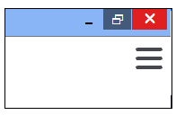

* Click the three lines at the top right corner.

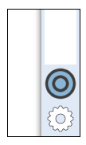

* Click the Gear/Settings icon at the bottom.

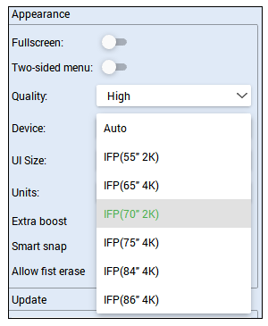

* In the appearance section, click the drop-down arrow for device and change it from Auto to IFP (70” 2K)

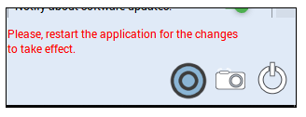

* Close, then reopen the program.